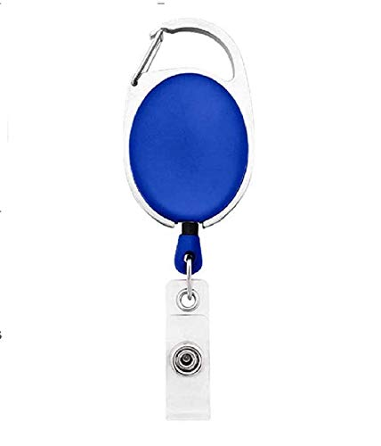

EMPLOYEE CARD

***EMP2345***

|  |  |
| --- | --- |
| **SARA MELENDEZ** | PHOTO |
| **IA** |
| **Joining:01/28/2022** |
| **Blood Group:AB-VE** |
| **Phone:8754906578** |

www.companywebsite.com